Mobile Web Design

Responsive vs. Adaptive

Elita Danilyuk  
 Computer Science  
 Colorado State University  
 Fort Collins CO USA  
elita@colostate.edu

ABSTRACT

Should web applications be automatically developed to be mobile-friendly? Mobile devices are used differently than computers. Doesn’t that mean they should be developed with different uses in mind? Creating a website that is designed well across different devices can have a responsive or adaptive design all while posing different drawbacks and benefits.

This paper will go into detail about giving users accessibility across various devices and which design implementation (responsive or adaptive) is better suited for the product.

CCS CONCEPTS

• Interaction Design • Human-computer Interaction • User Characteristics • Visualization • Accessibility • Cross-computing Tools and Techniques • Software Creation and Management • Ubiquitous and Mobile Computing • World Wide Web

KEYWORDS

Web design, Web development, Mobile development, Web applications, World wide web

1 Introduction

Software development is continuously changing and is closely correlated to how users browse the web. As Imed Bouchrika, the chief data scientist of research.com, states, “…user experience becomes tied to the success or failure of a website or an application,” [6].

Moreover, because user experience is so closely tied with the acceptance to web applications, it is important to develop said applications to be ‘approved’ by the users. This being said, the number of users who browse the web on their mobile devices in increasing exponentially. As of February 2022, the study, “Desktop vs Mobile Market Share Worldwide,” by statcounter, found that

Permission to make digital or hard copies of part or all of this work for personal or classroom use is granted without fee provided that copies are not made or distributed for profit or commercial advantage and that copies bear this notice and the full citation on the first page. Copyrights for third-party components of this work must be honored. For all other uses, contact the owner/author(s).

© 2022 Copyright held by the owner/author(s).

57.44% of web traffic is generated from mobile devices while desktops were responsible for 42.56% of web traffic [7]. This is a simple example of why developing web applications with various devices in mind is important.

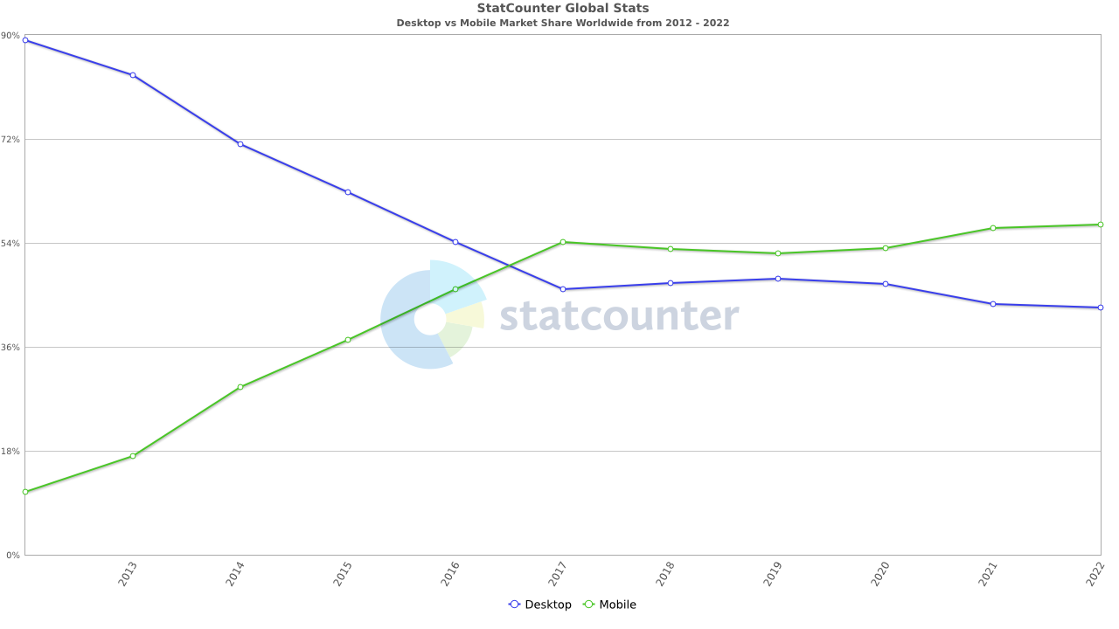

Figure 1: A line chart depicting the statcounter study “Desktop vs Mobile Market Share Worldwide” – 2012 to 2022.

However, although web browsing on mobile devices is increasing, this does not mean the development of web applications should only consider mobile friendly applications. Laptops and desktop computers are better performers and are more suitable for applications which require larger computations. This goes to show that the need for developers to consider various device experiences is considerably increasing.

Based off known data on web traffic across device types, should developers design their web applications with the automatic assumption that their websites will be accessed from mobile devices?

2 Importance of Mobile Web Design

With the advanced development of mobile devices, web developers can no longer ignore the use of mobile devices as a significant source of web browsing. Therefore, websites and web applications should be easily viewable on mobile devices. If the web application is considered difficult to navigate because of its limitations on mobile devices, it is very likely that the web application will lose their users, therefore, driving less traffic away from their web app.

Regarding the accessibility of mobile devices to browse the web, Google changed their algorithm when users search on their mobile device to promote mobile ready sites before websites that are not designed for mobile devices [8].

Google has taken the initiative to improve their user experience and accessibility by making their mobile indexing sort results by ‘mobile-first’ websites. Google’s users predominantly access Google Search on their mobile devices. This is why, on July 1, 2019, Google decided to further enable mobile-first indexing for all new websites [9]. Mobile-first indexing means that Google will largely use the mobile version of content for their indexing and raking of search results. In March 2022 Google used a smartphone Googlebot and found that 70% of sites in search results were prepared for mobile-first indexing [10]. Since September of 2020, Google has switched to mobile-first indexing for **all** websites.

Although, Google is the world’s largest search engine at a market share of 91.6% compared to Bing’s market share of 3.02%, according to, “Desktop & Mobile Search Engine Market Share Worldwide – Mar 2022,” by statcounter [11]. It should be noted that not all search engines have implemented mobile-first indexing. In response to Google’s announcement, Bing decided not to implement the same mobile-first indexing.

However, to answer the question previously posed as to whether developers should design their websites with the assumption that their websites will be accessed from mobile devices, the answer is yes. Although developers working on **new** websites should definitely assume their website will be accessed by mobile devices (edge cases excluded), developers should also heavily consider redesigning­ existing websites to be mobile friendly.

Web developers now having to significantly consider mobile accessibility raises a new question. How does one develop a website/web application to be mobile friendly? What are the options, and which one is better suited for the product?

To answer these questions, one should understand the two types of mobile friendly design, responsive and adaptive, and what they offer.

3 Responsive Web Design Summary

The tern Responsive Web Design was popularized by Ethan Marcotte, a developer and web designer, from his book, *Responsive Web Design*. Responsive web design adjusts and responds to changes in browser width. Thus, it changes the layout of a website in a fluid motion [2]. Responsive designers can create a single design which will be used on all screens and devices. They then use media queries to determine what adjustments need to be made for lower and higher ends of the resolution scale.

Since responsive web design does not change the content of a web site, users tend to be happier because the design is somewhat guaranteed, uniform, and seamless across devices.

Responsive design may be straightforward, but it does require a deep understanding of the site and the needs and wants of the users. This being said, responsive design is significantly easier and takes less work, therefore less time, to implement. Responsive design does not require much control over the web design for each screen size. Therefore, responsive web design is largely becoming the preferred method to create new web sites. It should be noted that this may be correlated to the increase of affordable templates online that are available for Content Management Systems (CMS), such as WordPress and Squarespace. [2]

Figure 2: A depiction of how responsive design correlates across various devices.

Overall, responsive design is a great choice when it comes to budget, time, and implementation. It is great for small to medium-sized companies, new business, and service-based industries.

4 Adaptive Web Design Summary

Adaptive Web Design was popularized and coined by Aaron Gustafson, a web designer, in his book *Adaptive Web Design: Crafting Rich Experiences with Progressive Enhancement*. Adaptive design detects the browsers size and then selects the layout that is the most appropriate for the screen. For example, if a user opens a browser on their laptop, the site would choose the best layout for that laptop screen and resizing the browser would have no change on the design.

Many highly targeted sites, such as Amazon, Apple, and USA Today, have turned to adaptive web design. The layout of these sites on a mobile phone may be different from the same website on a laptop; this is because the developers chose a different layout for different devices, rather than leaving the site to rearrange itself.

Since adaptive design is developed for different devices, the most common screen widths to design for are: 320, 480, 760, 960, 1200, and 1600 pixels. Thus, the current standard is to maintain six designs, depending on user data (it may turn out to be less than six).

Figure 3: A depiction of how adaptive design correlates across various devices.

Overall, adaptive web design is a good design choice when a site is speed-dependent and is highly targeted by users (adaptive sites render faster than responsive sites). The main advantage of adaptive design is that it allows for more design control.

Conclusion

Before moving forward, lets revisit the advantages and disadvantages of both responsive and adaptive web design.

Responsive web design advantages:

* Ensures uniformity of the web site across multiple devices and screen resolutions
* More search engine friendly, “*… sites that use responsive web design, i.e. sites that serve all devices on the same set of URLs, with each URL serving the same HTML to all devices and using just CSS to change how the page is rendered on the device. This is Google’s recommended configuration.*” [3]
* Since all the website content is contained in one URL, it allows for simplicity and allows for easy social media sharing, bookmarks, web statistics, and search engine rankings [3]
* Only one version of a web site will require less maintenance
* Cost effective
* Faster development and implementation

Responsive web design disadvantages:

* Changes in widths of the website may cause issues with advertisements
* Load times for responsive web sites may be slower due to image resolutions

Adaptive web design advantages:

* Ensures best user experience for all users, regardless of their device
* Advertisements can be easily optimized based on the different mobile and desktop web site designs
* Web sites render faster than responsive web sites
* Allows for significant design control

Adaptive web design disadvantages:

* Cross-linking is required
* May hurt your site visits by users, due to hindered search engine results
* Since there are multiple versions of a web site, maintainability is significantly more difficult
* More expensive and time costly

Furthermore, are some helpful recommendations of which to choose from:

* Responsive web design [5]:
  + Small to medium-sized companies that need to update their existing sites
  + New business that need to build a new web site
  + Service-based industries because of their significant use of images and text
* Adaptive web design [5]:
  + Existing complex web sites that require a mobile version
  + Speed-dependent web sites
  + Sites which are highly targeted by users to enhance their experience (their experience can be adapted to their location, connection speed, and more)
  + A web site that needs more control

Overall, one should make an informative decision on whether responsive or adaptive web design is the best choice for designing their web site. Look over the advantages and disadvantages of both options and strongly consider what the current development stage is and where it may go in the future.

One final recommendation, regardless of choosing between responsive or adaptive web design, one should check the mobile readiness of a site by visiting Google’s Mobile-Friendly test site [12].

REFERENCES

[2] Mads Soegaard. 2021. Adaptive vs. Responsive Design. (2021). Retrieved February 16, 2022 from https://www.interaction-design.org/literature/article/adaptive-vs-responsive-design

­­[3] Sufyan bin Uzayr. 2019. Responsive vs. Adaptive Design. (September 2019). Retrieved February 16, 2022 from https://torquemag.io/2013/09/responsive-design-vs-adaptive-design/Conference Name:ACM Woodstock conference

[5] Tomas Laurinavicius. 2019. Adaptive vs responsive design: Which is better?: Webflow blog. (August 2019). Retrieved February 16, 2022 from https://webflow.com/blog/adaptive-vs-responsive-design

[6] Bouchrika, Imed 2021. Mobile vs Desktop Usage Statistics for 2021/2022. (February 2021). Retrieved March 28, 2022 from https://research.com/software/mobile-vs-desktop-usage#:~:text=When%20it%20comes%20to%20mobile,of%20the%20total%20web%20traffic

[7] Desktop vs Mobile Market Share Worldwide. Retrieved March 28, 2022 from https://gs.statcounter.com/platform-market-share/desktop-mobile/worldwide/#yearly-2012-2022

[8] Should My Online Store Be Responsive, Adaptive, or Mobile First? (May 2020). Retrieved March 28, 2022 from https://www.venturawebdesign.com/responsive-vs-mobile-website-design/

[9] Mobile-First Indexing Best Practices. Retrieved March 28, 2022 from https://developers.google.com/search/mobile-sites/mobile-first-indexing

[10] Announcing Mobile First Indexing for the Whole Web (March 2020). Retrieved March 28, 2022 from https://developers.google.cn/search/blog/2020/03/announcing-mobile-first-indexing-for?hl=pl

[11] Desktop & Mobile Search Engine Market Share Worldwide. Retrieved March 28, 2022 from https://gs.statcounter.com/search-engine-market-share/desktop-mobile/worldwide/#monthly-202203-202203-bar

[12] Is Your Web Page Mobile-Friendly? Retrieved March 28, 2022 from https://Search.google.com/Test/Mobile-Friendly?utm_source=Mft&utm_medium=Redirect&utm_campaign=Mft-Redirect